Skypilot Selection Analyses__PP_75 - SM_2.5 Part 2

Valerie Martin

8/25/2019

## Skypilot Selection Analyse with 75% Pollination Percentage and 2.5 Seed Maturity

#### Loading data and creating subsets…

setwd("~/Desktop/Skypilot 2017")  
library(ggplot2)  
library(plyr)  
library(nlme)  
library(car)

## Loading required package: carData

library(emmeans)  
library(multcompView)  
  
fruit <- read.csv("Skypilot 2017 (MASTER) Tab3 08-12-19.csv", header=T) # all data included (final)  
fruit$OtherSeedcount[is.na(fruit$OtherSeedcount)] <- 0  
fruit$Total.SeedsPerPlant <- fruit$No.TrmtSeeds+fruit$OtherSeedcount  
  
cols <- c("Site", "Habitat", "Treatment", "Plant.Number", "Morph", "No.Pollinated.Total", "Total.RepUnits", "Prct.Pollinated",  
 "Avg.SepL", "Avg.TubeL", "Avg.LobeL", "Avg.LobW", "Avg.CorollaFlare", "No.SeedsPerFruit", "Fruit.Maturity.Rank",   
 "Total.SeedsPerFruit", "Total.SeedsPerPlant")  
fruit.sm <- subset(fruit, select=cols) # remove raw data columns  
  
fruit.sm <- subset(fruit.sm, Avg.CorollaFlare>0) # remove those without flower measurements  
fruit.sm$Prct.Pollinated <- as.numeric(as.character(fruit.sm$Prct.Pollinated)) # change Prct.Pollinated to numeric (it was a factor)  
fruit.sm <- subset(fruit.sm, !(Treatment=="Supplementation" & Prct.Pollinated < 0.75)) # remove those supplement flowers with <75% fruits pollinated  
fruit.sm <- subset(fruit.sm, Fruit.Maturity.Rank < 2.5) # remove fruit maturity 2.5 (includes all exlusion as well)   
fruit.sm$CorollaL <- fruit.sm$Avg.TubeL + fruit.sm$Avg.LobeL  
max(fruit.sm$Total.SeedsPerPlant)

## [1] 138

fruit.sm$RelativeFitness <- fruit.sm$Total.SeedsPerPlant/138  
  
  
fruit.sw <- subset(fruit.sm, Morph=="Sweet") # subst to sweet morph only  
fruit.sw.np <- subset(fruit.sw, Site %in% c("Niwot Ridge", "Penn Mountain"))  
fruit.sw.nat <- subset(fruit.sw, Treatment=="Natural")  
fruit.sw.sup <- subset(fruit.sw, Treatment=="Supplementation")  
fruit.nat <- subset(fruit.sm, Treatment=="Natural") # subset to natural treatment only  
fruit.sup <- subset(fruit.sm, Treatment=="Supplementation") # subset to supplement treatment only  
fruit.np <- subset(fruit.sm, Site %in% c("Niwot Ridge", "Penn Mountain"))  
  
flwr <- subset(fruit, Avg.CorollaFlare>0) # remove those without flower measurements  
flwr.nat <- subset(flwr, Treatment=="Natural") # subset to natural treatment only

### Supplementation Experiment

Niki: “Can’t use cumberland pass (no supplmement seeds were successfully collected…triple checking that). Marginal interaction effect: total seeds per plant increased with supplementation of skunky, but not sweet, flowers. Sweet has this weird relationship where sup seedset goes up with flower size. Jake swears size differences shouldn’t have influenced the effectiveness of the treatment.”

#### Sweet morph only

Niki: “no effect of habitat => remove no treatment effect, but Candi saw this in some years - might it relate to weaking selection?”

qqnorm(fruit.sw.np$Total.SeedsPerPlant)  
qqline(fruit.sw.np$Total.SeedsPerPlant)

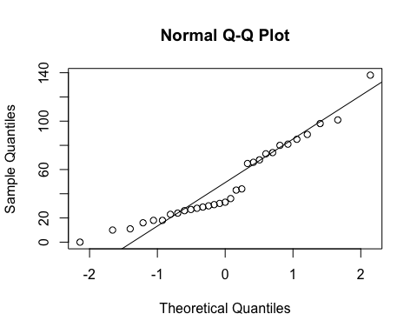

hist(fruit.sw.np$Total.SeedsPerPlant)

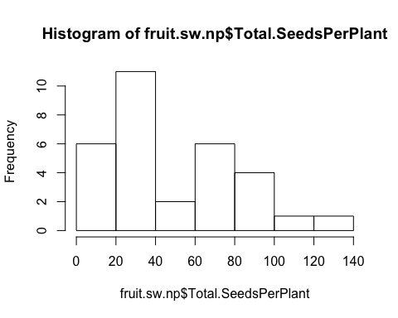

qqnorm(sqrt(fruit.sw.np$Total.SeedsPerPlant))  
qqline(sqrt(fruit.sw.np$Total.SeedsPerPlant))

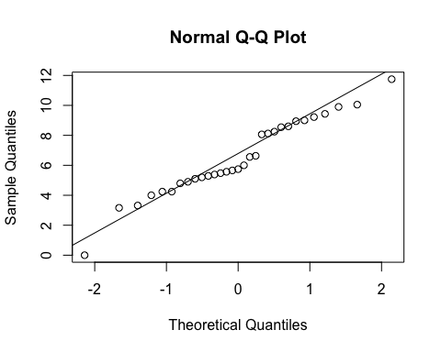

hist(sqrt(fruit.sw.np$Total.SeedsPerPlant))

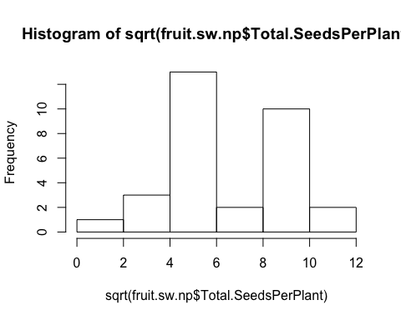

basic.lm <- lm(sqrt(Total.SeedsPerPlant)~Treatment, data=fruit.sw.np)  
(prelim.plot <- ggplot(fruit.sw.np, aes(x=Treatment, y = Total.SeedsPerPlant))) +  
 geom_point()+  
 geom_smooth(method = "lm")

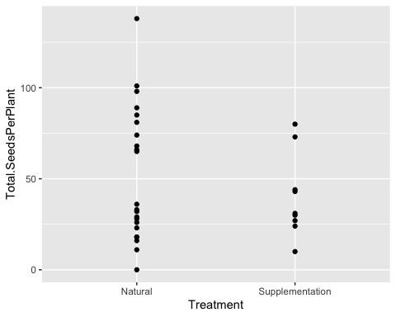

boxplot(Total.SeedsPerPlant ~ Treatment, data=fruit.sw.np)

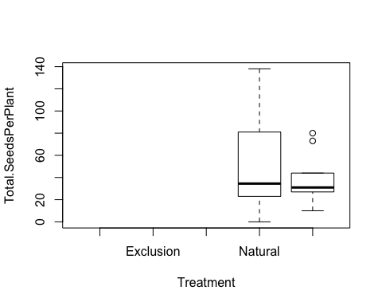

### Selection - sweet flowers only

##### Would experience the strongest selection and sk flowers biased by habitat (almost exclusively in the krummholz).

##### Including Cumberland pass - replication is low but not biased.

#### Seeds per plant

qqnorm(fruit.sw.nat$Total.SeedsPerPlant)  
qqline(fruit.sw.nat$Total.SeedsPerPlant)

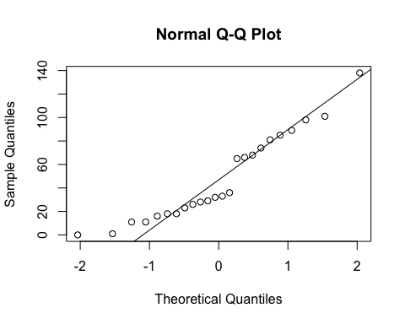

hist(fruit.sw.nat$Total.SeedsPerPlant)

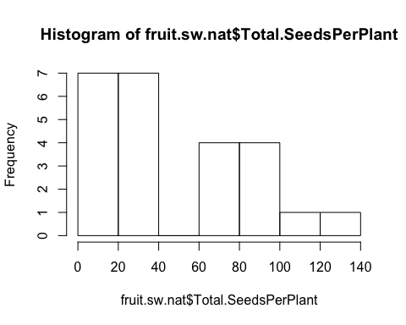

qqnorm(sqrt(fruit.sw.nat$Total.SeedsPerPlant))  
qqline(sqrt(fruit.sw.nat$Total.SeedsPerPlant))

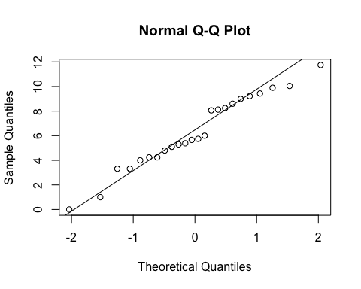

hist(sqrt(fruit.sw.nat$Total.SeedsPerPlant))

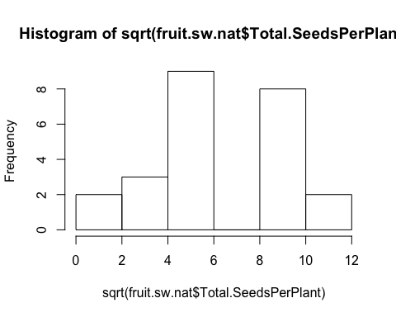

#### Site

anova(lm(sqrt(Total.SeedsPerPlant)~Site, data=fruit.sw.nat, na.action=na.omit))

## Analysis of Variance Table  
##   
## Response: sqrt(Total.SeedsPerPlant)  
## Df Sum Sq Mean Sq F value Pr(>F)  
## Site 2 36.933 18.4664 2.3277 0.1222  
## Residuals 21 166.601 7.9334

TukeyHSD(aov(sqrt(Total.SeedsPerPlant)~Site, data=fruit.sw.nat, na.action=na.omit))

## Tukey multiple comparisons of means  
## 95% family-wise confidence level  
##   
## Fit: aov(formula = sqrt(Total.SeedsPerPlant) ~ Site, data = fruit.sw.nat, na.action = na.omit)  
##   
## $Site  
## diff lwr upr p adj  
## Niwot Ridge-Cumberland Pass 4.3977418 -1.5421295 10.337613 0.1732965  
## Penn Mountain-Cumberland Pass 4.5110782 -0.7961207 9.818277 0.1053194  
## Penn Mountain-Niwot Ridge 0.1133363 -3.4985153 3.725188 0.9965576

ggplot(fruit.sw.nat, aes(x=Site,y=Total.SeedsPerPlant)) +  
 geom_boxplot() +   
 scale_y_sqrt()+  
 theme_bw() +  
 theme(panel.grid.major = element_blank(), panel.grid.minor = element_blank(), text = element_text(size=20))

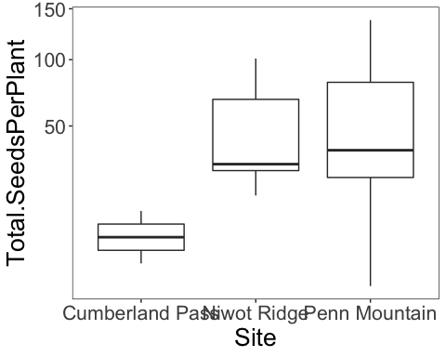

#### Corolla Flare

fit<-lme(sqrt(Total.SeedsPerPlant)~Avg.CorollaFlare, random=~1|Site, data=fruit.sw.nat, method="ML", na.action=na.omit)   
anova.lme(fit)

## numDF denDF F-value p-value  
## (Intercept) 1 20 102.46415 <.0001  
## Avg.CorollaFlare 1 20 0.10458 0.7498

ggplot(fruit.sw.nat, aes(x=Avg.CorollaFlare,y=Total.SeedsPerPlant, color=Site)) +  
 geom_point(size=4) +   
 scale_y_sqrt()+  
 ylab("Seeds per plant") +  
 xlab("Corolla flare") +   
 geom_hline(yintercept=0) +  
 theme_bw() +  
 theme(panel.grid.major = element_blank(), panel.grid.minor = element_blank(), text = element_text(size=20), legend.position = "top")

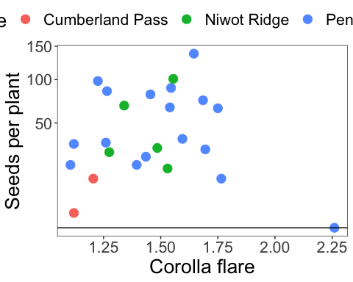

fit<-lm(sqrt(Total.SeedsPerPlant)~Avg.CorollaFlare*Site, data=fruit.sw.nat, na.action=na.omit)   
Anova(fit, type="III")

## Anova Table (Type III tests)  
##   
## Response: sqrt(Total.SeedsPerPlant)  
## Sum Sq Df F value Pr(>F)  
## (Intercept) 2.327 1 0.2808 0.6027  
## Avg.CorollaFlare 2.683 1 0.3237 0.5764  
## Site 6.942 2 0.4187 0.6641  
## Avg.CorollaFlare:Site 5.680 2 0.3426 0.7144  
## Residuals 149.200 18

#### Tube Length

fit<-lme(sqrt(Total.SeedsPerPlant)~Avg.TubeL, random=~1|Site, data=fruit.sw.nat, method="ML", na.action=na.omit)   
anova.lme(fit)

## numDF denDF F-value p-value  
## (Intercept) 1 20 104.29029 <.0001  
## Avg.TubeL 1 20 0.49853 0.4883

ggplot(fruit.sw.nat, aes(x=Avg.TubeL,y=Total.SeedsPerPlant, color=Site)) +  
 geom_point(size=4) +   
 scale_y_sqrt()+  
 ylab("Seeds per plant") +  
 xlab("Tube length") +   
 geom_hline(yintercept=0) +  
 theme_bw() +  
 theme(panel.grid.major = element_blank(), panel.grid.minor = element_blank(), text = element_text(size=20), legend.position = "top")

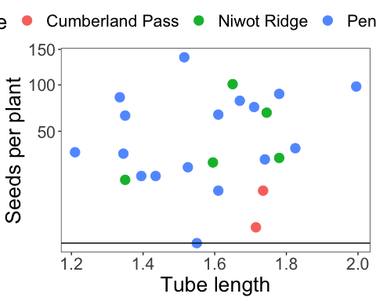

fit<-lm(sqrt(Total.SeedsPerPlant)~Avg.TubeL*Site, data=fruit.sw.nat, na.action=na.omit)   
Anova(fit, type="III")

## Anova Table (Type III tests)  
##   
## Response: sqrt(Total.SeedsPerPlant)  
## Sum Sq Df F value Pr(>F)  
## (Intercept) 2.626 1 0.3156 0.5812  
## Avg.TubeL 2.683 1 0.3225 0.5771  
## Site 4.405 2 0.2647 0.7704  
## Avg.TubeL:Site 4.111 2 0.2471 0.7837  
## Residuals 149.764 18

### Flower measurements combined via PCA

#### Flower measurements combined via PCA - Tube Length

cor(fruit.sw.nat$Avg.CorollaFlare,fruit.sw.nat$Avg.TubeL)

## [1] 0.07765206

cor.test(fruit.sw.nat$Avg.CorollaFlare,fruit.sw.nat$Avg.TubeL)

##   
## Pearson's product-moment correlation  
##   
## data: fruit.sw.nat$Avg.CorollaFlare and fruit.sw.nat$Avg.TubeL  
## t = 0.36532, df = 22, p-value = 0.7184  
## alternative hypothesis: true correlation is not equal to 0  
## 95 percent confidence interval:  
## -0.3362784 0.4664378  
## sample estimates:  
## cor   
## 0.07765206

plot(fruit.sw.nat$Avg.CorollaFlare,fruit.sw.nat$Avg.TubeL)

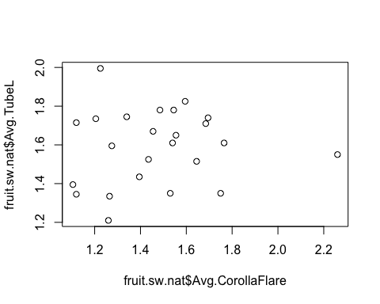

measures <- c("Avg.CorollaFlare", "Avg.TubeL")  
flwr.size<-as.matrix(subset(fruit.sw.nat, select=measures))  
pc<-princomp(flwr.size)  
pc<-prcomp(flwr.size,center=TRUE)  
print(pc)

## Standard deviations (1, .., p=2):  
## [1] 0.2655327 0.1919107  
##   
## Rotation (n x k) = (2 x 2):  
## PC1 PC2  
## Avg.CorollaFlare -0.9929312 0.1186915  
## Avg.TubeL -0.1186915 -0.9929312

plot(pc, type="l")

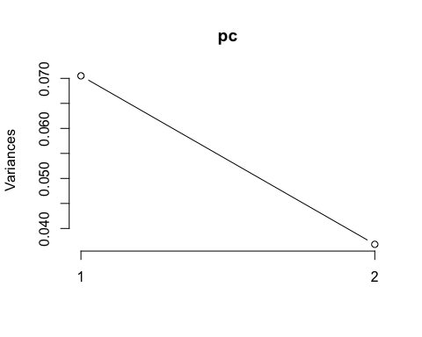

summary(pc)

## Importance of components:  
## PC1 PC2  
## Standard deviation 0.2655 0.1919  
## Proportion of Variance 0.6569 0.3431  
## Cumulative Proportion 0.6569 1.0000

pc.extracted <- as.data.frame(predict(pc, newdata=fruit.sw.nat))  
fruit.sw.nat$PC1 <- pc.extracted$PC1

#### Flower measurement combined via PCA - Corolla Length

fruit.sw.nat$CorollaL <- fruit.sw.nat$Avg.TubeL + fruit.sw.nat$Avg.LobeL  
cor(fruit.sw.nat$Avg.CorollaFlare,fruit.sw.nat$CorollaL)

## [1] 0.4511303

cor.test(fruit.sw.nat$Avg.CorollaFlare,fruit.sw.nat$CorollaL)

##   
## Pearson's product-moment correlation  
##   
## data: fruit.sw.nat$Avg.CorollaFlare and fruit.sw.nat$CorollaL  
## t = 2.371, df = 22, p-value = 0.02692  
## alternative hypothesis: true correlation is not equal to 0  
## 95 percent confidence interval:  
## 0.05835285 0.72295956  
## sample estimates:  
## cor   
## 0.4511303

plot(fruit.sw.nat$Avg.CorollaFlare,fruit.sw.nat$CorollaL)

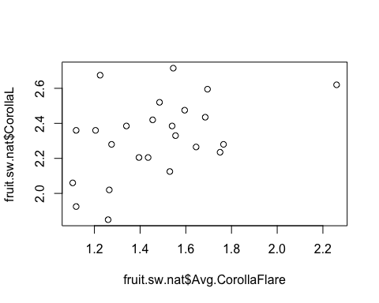

measures <- c("CorollaL", "Avg.CorollaFlare")  
flwr.size<-as.matrix(subset(fruit.sw.nat, select=measures))  
pc<-prcomp(flwr.size,center=TRUE)  
print(pc)

## Standard deviations (1, .., p=2):  
## [1] 0.2979192 0.1779617  
##   
## Rotation (n x k) = (2 x 2):  
## PC1 PC2  
## CorollaL 0.5726924 0.8197704  
## Avg.CorollaFlare 0.8197704 -0.5726924

plot(pc, type="l")

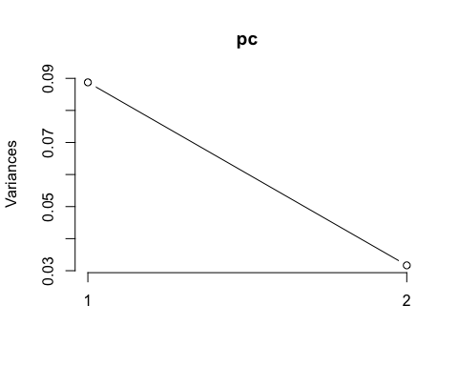

summary(pc)

## Importance of components:  
## PC1 PC2  
## Standard deviation 0.2979 0.178  
## Proportion of Variance 0.7370 0.263  
## Cumulative Proportion 0.7370 1.000

pc.extracted <- as.data.frame(predict(pc, newdata=fruit.sw.nat))  
fruit.sw.nat$PC1.cl <- pc.extracted$PC1

#### Flower measurements combined via pca (all 4 traits - same as pressed)

measures <- c("Avg.CorollaFlare", "Avg.TubeL", "Avg.LobeL", "Avg.LobW")  
flwr.size<-as.matrix(subset(fruit.sw.nat, select=measures))  
pc<-prcomp(flwr.size,center=TRUE)  
print(pc)

## Standard deviations (1, .., p=4):  
## [1] 0.29408912 0.19231785 0.06706734 0.05112285  
##   
## Rotation (n x k) = (4 x 4):  
## PC1 PC2 PC3 PC4  
## Avg.CorollaFlare -0.89383142 0.06820674 -0.36362083 -0.25336361  
## Avg.TubeL -0.08435587 -0.99591155 0.02959356 -0.01298049  
## Avg.LobeL -0.31121682 0.05660896 0.92433476 -0.21341219  
## Avg.LobW -0.31159840 0.01741986 0.11184526 0.94344773

plot(pc, type="l")

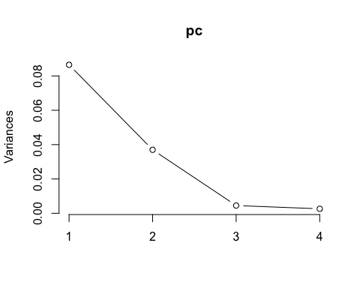

summary(pc)

## Importance of components:  
## PC1 PC2 PC3 PC4  
## Standard deviation 0.2941 0.1923 0.06707 0.05112  
## Proportion of Variance 0.6623 0.2832 0.03444 0.02001  
## Cumulative Proportion 0.6623 0.9455 0.97999 1.00000

pc.extracted <- as.data.frame(predict(pc, newdata=fruit.sw.nat))  
##### Inverted PC1 when added to the df, because all loadings were negative. This way, larger PC denotes a larger flower.  
fruit.sw.nat$PC1.all <- -pc.extracted$PC1

#### Total seedset per plant (annual fecundity)

fit<-lme(sqrt(Total.SeedsPerPlant)~PC1.all, random=~1|Site, data=fruit.sw.nat, method="ML", na.action=na.omit)   
anova.lme(fit)

## numDF denDF F-value p-value  
## (Intercept) 1 20 102.3451 <.0001  
## PC1.all 1 20 0.0789 0.7817

ggplot(fruit.sw.nat, aes(x=PC1,y=Total.SeedsPerPlant, color=Site)) +  
 geom_point(size=4) +   
 scale_y_sqrt()+  
 ylab("Seeds per plant") +  
 xlab("PC1") +   
 geom_hline(yintercept=0) +  
 theme_bw() +  
 theme(panel.grid.major = element_blank(), panel.grid.minor = element_blank(), text = element_text(size=20), legend.position = "top")

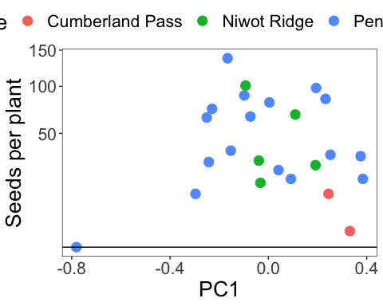

fit<-lme(sqrt(Total.SeedsPerPlant)~PC1.cl, random=~1|Site, data=fruit.sw.nat, method="ML", na.action=na.omit)   
anova.lme(fit)

## numDF denDF F-value p-value  
## (Intercept) 1 20 101.99401 <.0001  
## PC1.cl 1 20 0.00316 0.9558

#### Relative fecundity (standardized by max annual fecundity)

max(fruit.sw.nat$Total.SeedsPerPlant)

## [1] 138

fruit.sw.nat$RelativeFitness <- fruit.sw.nat$Total.SeedsPerPlant/138  
  
qqnorm(fruit.sw.nat$RelativeFitness)  
qqline(fruit.sw.nat$RelativeFitness)

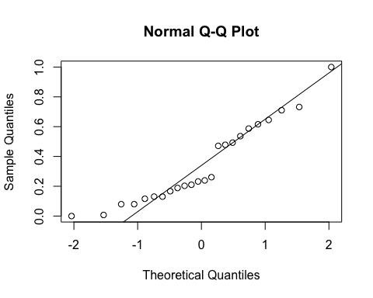

hist(fruit.sw.nat$RelativeFitness)

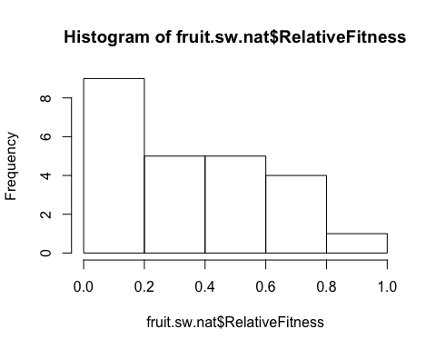

qqnorm(sqrt(fruit.sw.nat$RelativeFitness))  
qqline(sqrt(fruit.sw.nat$RelativeFitness))

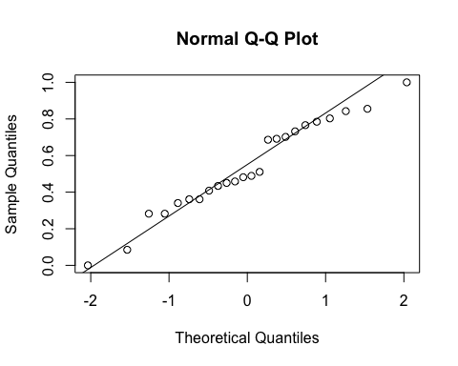

hist(sqrt(fruit.sw.nat$RelativeFitness))

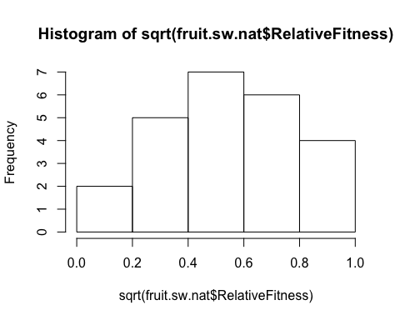

fit<-lme(sqrt(RelativeFitness)~PC1, random=~1|Site, data=fruit.sw.nat, method="ML", na.action=na.omit)   
anova.lme(fit)

## numDF denDF F-value p-value  
## (Intercept) 1 20 102.29124 <.0001  
## PC1 1 20 0.06728 0.798

ggplot(fruit.sw.nat, aes(x=PC1,y=RelativeFitness)) +  
 geom_point(size=2) +   
 scale_y_sqrt()+  
 scale_colour_manual(values=c("black")) +  
 ylab("Relative fitness") +  
 xlab("PC1") +   
 geom_hline(yintercept=0) +  
 theme_bw() +  
 theme(panel.grid.major = element_blank(), panel.grid.minor = element_blank(), text = element_text(size=20))

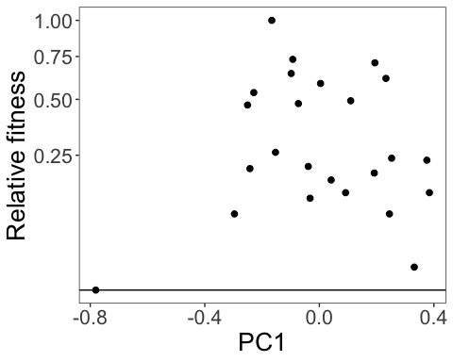

fit<-lme(sqrt(RelativeFitness)~PC1.cl, random=~1|Site, data=fruit.sw.nat, method="ML", na.action=na.omit)   
anova.lme(fit)

## numDF denDF F-value p-value  
## (Intercept) 1 20 101.99401 <.0001  
## PC1.cl 1 20 0.00316 0.9558

ggplot(fruit.sw.nat, aes(x=PC1.cl,y=RelativeFitness)) +  
 geom_point(size=2) +   
 scale_y_sqrt()+  
 scale_colour_manual(values=c("black")) +  
 xlim(-1,1) +  
 ylab("Relative fitness") +  
 xlab("PC1") +   
 geom_hline(yintercept=0) +  
 theme_bw() +  
 theme(panel.grid.major = element_blank(), panel.grid.minor = element_blank(), text = element_text(size=20))

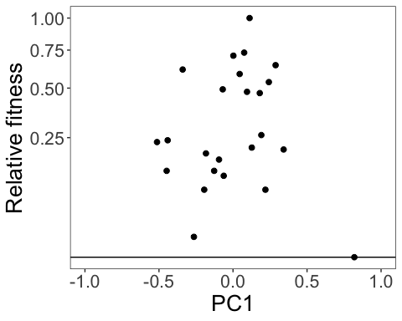

fit<-lme(sqrt(RelativeFitness)~Avg.CorollaFlare, random=~1|Site, data=fruit.sw.nat, method="ML", na.action=na.omit)   
anova.lme(fit)

## numDF denDF F-value p-value  
## (Intercept) 1 20 102.46415 <.0001  
## Avg.CorollaFlare 1 20 0.10458 0.7498

ggplot(fruit.sw.nat, aes(x=CorollaL,y=RelativeFitness)) +  
 geom_point(size=2) +   
 scale_y_sqrt()+  
 ylab("Relative fitness") +  
 xlab("Corolla flare (cm)") +   
 geom_hline(yintercept=0) +  
 theme_bw() +  
 theme(panel.grid.major = element_blank(), panel.grid.minor = element_blank(), text = element_text(size=20))

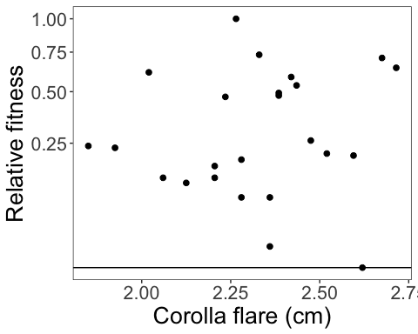

fit<-lme(sqrt(RelativeFitness)~CorollaL, random=~1|Site, data=fruit.sw.nat, method="ML", na.action=na.omit)   
anova.lme(fit)

## numDF denDF F-value p-value  
## (Intercept) 1 20 102.78108 <.0001  
## CorollaL 1 20 0.17295 0.6819

ggplot(fruit.sw.nat, aes(x=CorollaL,y=RelativeFitness)) +  
 geom_point(size=2) +   
 scale_y_sqrt()+  
 ylab("Relative fitness") +  
 xlab("Corolla length (cm)") +   
 geom_hline(yintercept=0) +  
 theme_bw() +  
 theme(panel.grid.major = element_blank(), panel.grid.minor = element_blank(), text = element_text(size=20))

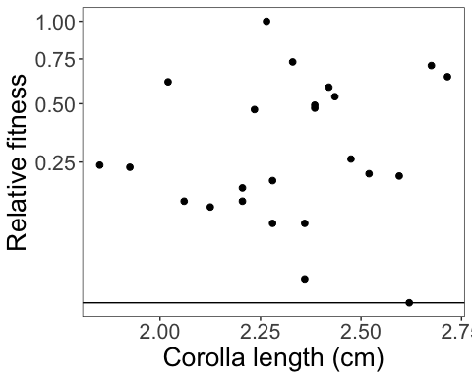

fit<-lme(sqrt(RelativeFitness)~Avg.TubeL, random=~1|Site, data=fruit.sw.nat, method="ML", na.action=na.omit)   
anova.lme(fit)

## numDF denDF F-value p-value  
## (Intercept) 1 20 104.29029 <.0001  
## Avg.TubeL 1 20 0.49853 0.4883

ggplot(fruit.sw.nat, aes(x=Avg.TubeL,y=RelativeFitness)) +  
 geom_point(size=2) +   
 scale_y_sqrt()+  
 ylab("Relative fitness") +  
 xlab("Flower tube length (cm)") +   
 geom_hline(yintercept=0) +  
 theme_bw() +  
 theme(panel.grid.major = element_blank(), panel.grid.minor = element_blank(), text = element_text(size=20))

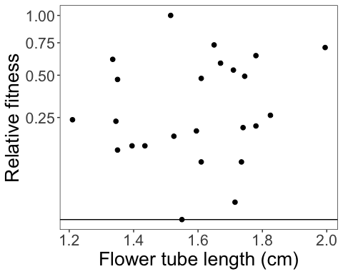

### With supplementation treatment

##### (treatment was more effective for larger flowers…Jake swears flwr size didn’t affect the trmt)

#### Total seedset per plant

qqnorm(fruit.sw$Total.SeedsPerPlant)  
qqline(fruit.sw$Total.SeedsPerPlant)

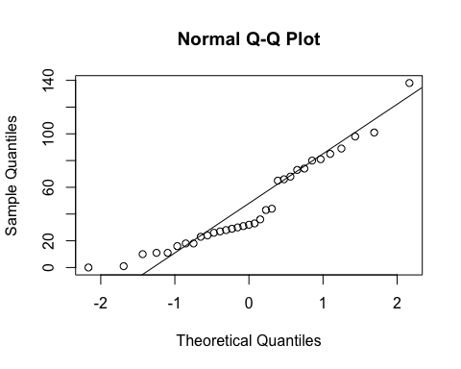

hist(fruit.sw$Total.SeedsPerPlant)

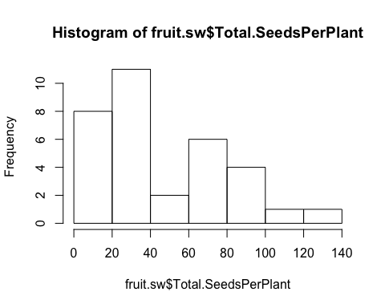

qqnorm(sqrt(fruit.sw$Total.SeedsPerPlant))  
qqline(sqrt(fruit.sw$Total.SeedsPerPlant))

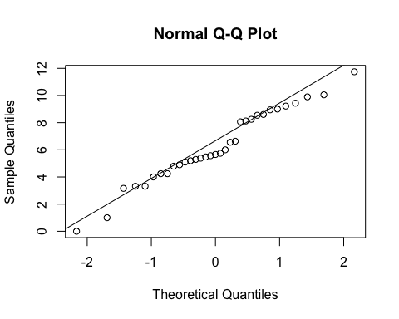

hist(sqrt(fruit.sw$Total.SeedsPerPlant))

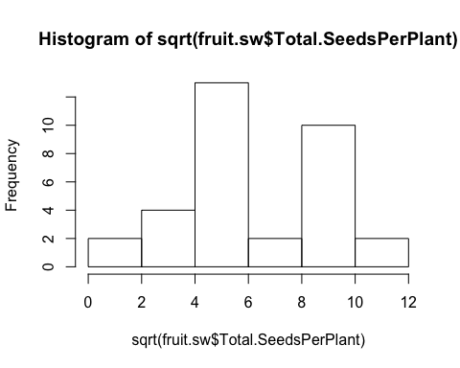

fit<-lme(sqrt(Total.SeedsPerPlant)~Treatment*Avg.CorollaFlare, random=~1|Site/Habitat, data=fruit.sw, method="ML", na.action=na.omit)   
anova.lme(fit)

## numDF denDF F-value p-value  
## (Intercept) 1 24 21.356462 0.0001  
## Treatment 1 24 0.275783 0.6043  
## Avg.CorollaFlare 1 24 0.737663 0.3989  
## Treatment:Avg.CorollaFlare 1 24 0.428068 0.5192

summary(fit)

## Linear mixed-effects model fit by maximum likelihood  
## Data: fruit.sw   
## AIC BIC logLik  
## 171.1115 181.5871 -78.55577  
##   
## Random effects:  
## Formula: ~1 | Site  
## (Intercept)  
## StdDev: 1.489304  
##   
## Formula: ~1 | Habitat %in% Site  
## (Intercept) Residual  
## StdDev: 0.9348935 2.386104  
##   
## Fixed effects: sqrt(Total.SeedsPerPlant) ~ Treatment * Avg.CorollaFlare   
## Value Std.Error DF  
## (Intercept) 8.821850 3.206563 24  
## TreatmentSupplementation -4.255062 5.850874 24  
## Avg.CorollaFlare -2.280919 2.113164 24  
## TreatmentSupplementation:Avg.CorollaFlare 2.489709 3.805328 24  
## t-value p-value  
## (Intercept) 2.7511857 0.0111  
## TreatmentSupplementation -0.7272524 0.4741  
## Avg.CorollaFlare -1.0793858 0.2911  
## TreatmentSupplementation:Avg.CorollaFlare 0.6542693 0.5192  
## Correlation:   
## (Intr) TrtmnS Avg.CF  
## TreatmentSupplementation -0.524   
## Avg.CorollaFlare -0.926 0.571   
## TreatmentSupplementation:Avg.CorollaFlare 0.528 -0.985 -0.587  
##   
## Standardized Within-Group Residuals:  
## Min Q1 Med Q3 Max   
## -1.7222221 -0.7196726 -0.3798795 0.7869317 2.0765876   
##   
## Number of Observations: 33  
## Number of Groups:   
## Site Habitat %in% Site   
## 3 6

ggplot(fruit.sw, aes(x=Avg.CorollaFlare,y=Total.SeedsPerPlant, color=Treatment, shape=Treatment)) +  
 scale_shape_manual(values=c(16,17)) +  
 geom_point(size=4) +   
 scale_y_sqrt()+  
 scale_colour_manual(values=c("blue", "red")) +  
 geom_smooth(method='lm', fill=NA) +  
 theme_bw() +  
 theme(panel.grid.major = element_blank(), panel.grid.minor = element_blank(), text = element_text(size=20))

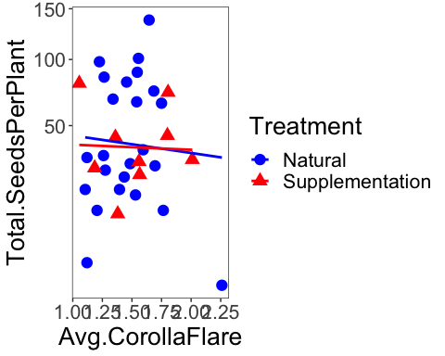

fit<-lme(sqrt(Total.SeedsPerPlant)~Avg.CorollaFlare, random=~1|Site/Habitat, data=fruit.sw.nat, method="ML", na.action=na.omit)   
anova.lme(fit)

## numDF denDF F-value p-value  
## (Intercept) 1 17 89.26396 <.0001  
## Avg.CorollaFlare 1 17 0.15478 0.6989

fit<-lme(sqrt(Total.SeedsPerPlant)~Avg.CorollaFlare, random=~1|Site/Habitat, data=fruit.sw.sup, method="ML", na.action=na.omit)   
anova.lme(fit)

## numDF denDF F-value p-value  
## (Intercept) 1 5 90.16391 0.0002  
## Avg.CorollaFlare 1 5 0.01070 0.9216

fit<-lme(sqrt(Total.SeedsPerPlant)~Treatment*Avg.TubeL, random=~1|Site/Habitat, data=fruit.sw, method="ML", na.action=na.omit)   
anova.lme(fit)

## numDF denDF F-value p-value  
## (Intercept) 1 24 37.11706 <.0001  
## Treatment 1 24 0.17806 0.6768  
## Avg.TubeL 1 24 0.21963 0.6435  
## Treatment:Avg.TubeL 1 24 1.43656 0.2424

fit<-lme(sqrt(Total.SeedsPerPlant)~Treatment*CorollaL, random=~1|Site/Habitat, data=fruit.sw, method="ML", na.action=na.omit)   
anova.lme(fit)

## numDF denDF F-value p-value  
## (Intercept) 1 24 149.86967 <.0001  
## Treatment 1 24 0.03528 0.8526  
## CorollaL 1 24 0.01927 0.8908  
## Treatment:CorollaL 1 24 1.21095 0.2821

#### Relative fitness

fit<-lme(sqrt(RelativeFitness)~Treatment*Avg.CorollaFlare, random=~1|Site, data=fruit.sw, method="ML", na.action=na.omit)   
anova.lme(fit)

## numDF denDF F-value p-value  
## (Intercept) 1 27 162.24188 <.0001  
## Treatment 1 27 0.02147 0.8846  
## Avg.CorollaFlare 1 27 0.10733 0.7457  
## Treatment:Avg.CorollaFlare 1 27 0.01986 0.8890

fit<-lme(sqrt(RelativeFitness)~Treatment*Avg.CorollaFlare, random=~1|Site, data=fruit.sw, method="ML", na.action=na.omit)   
anova.lme(fit)

## numDF denDF F-value p-value  
## (Intercept) 1 27 162.24188 <.0001  
## Treatment 1 27 0.02147 0.8846  
## Avg.CorollaFlare 1 27 0.10733 0.7457  
## Treatment:Avg.CorollaFlare 1 27 0.01986 0.8890

fit<-lme(sqrt(RelativeFitness)~Treatment*Avg.CorollaFlare, random=~1|Site, data=fruit.sw, method="ML", na.action=na.omit)   
anova.lme(fit)

## numDF denDF F-value p-value  
## (Intercept) 1 27 162.24188 <.0001  
## Treatment 1 27 0.02147 0.8846  
## Avg.CorollaFlare 1 27 0.10733 0.7457  
## Treatment:Avg.CorollaFlare 1 27 0.01986 0.8890

#### Seeds per fruit

qqnorm(fruit.sw$No.SeedsPerFruit)  
qqline(fruit.sw$No.SeedsPerFruit)

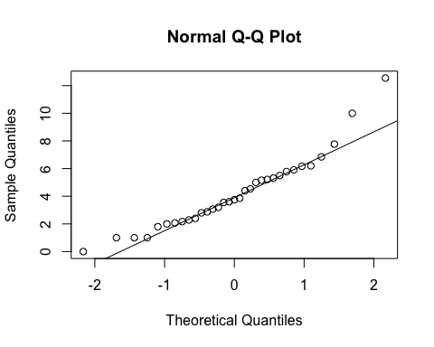

hist(fruit.sw$No.SeedsPerFruit)

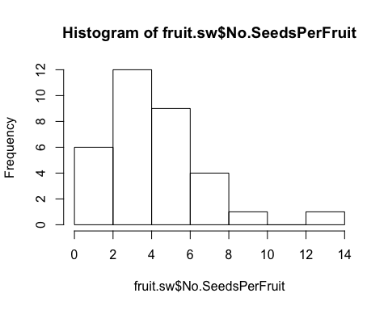

qqnorm(sqrt(fruit.sw$No.SeedsPerFruit))  
qqline(sqrt(fruit.sw$No.SeedsPerFruit))

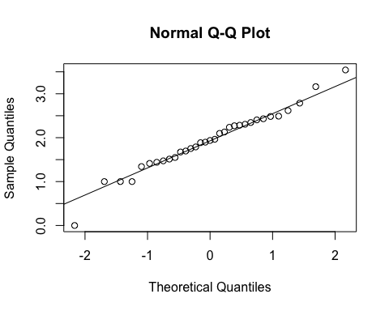

hist(sqrt(fruit.sw$No.SeedsPerFruit))

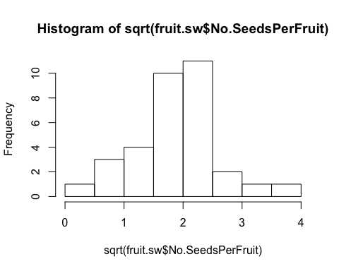

fit<-lme(sqrt(No.SeedsPerFruit)~Treatment*Avg.CorollaFlare, random=~1|Site/Habitat, data=fruit.sw, method="ML", na.action=na.omit)   
anova.lme(fit)

## numDF denDF F-value p-value  
## (Intercept) 1 24 192.18865 <.0001  
## Treatment 1 24 0.81257 0.3763  
## Avg.CorollaFlare 1 24 0.34061 0.5649  
## Treatment:Avg.CorollaFlare 1 24 0.23904 0.6293

summary(fit)

## Linear mixed-effects model fit by maximum likelihood  
## Data: fruit.sw   
## AIC BIC logLik  
## 80.06388 90.53943 -33.03194  
##   
## Random effects:  
## Formula: ~1 | Site  
## (Intercept)  
## StdDev: 2.041652e-05  
##   
## Formula: ~1 | Habitat %in% Site  
## (Intercept) Residual  
## StdDev: 0.1159267 0.649319  
##   
## Fixed effects: sqrt(No.SeedsPerFruit) ~ Treatment * Avg.CorollaFlare   
## Value Std.Error DF  
## (Intercept) 2.4569167 0.8182418 24  
## TreatmentSupplementation -0.4583646 1.4915181 24  
## Avg.CorollaFlare -0.4168601 0.5496686 24  
## TreatmentSupplementation:Avg.CorollaFlare 0.4754465 0.9724569 24  
## t-value p-value  
## (Intercept) 3.0026781 0.0062  
## TreatmentSupplementation -0.3073141 0.7613  
## Avg.CorollaFlare -0.7583844 0.4556  
## TreatmentSupplementation:Avg.CorollaFlare 0.4889126 0.6293  
## Correlation:   
## (Intr) TrtmnS Avg.CF  
## TreatmentSupplementation -0.553   
## Avg.CorollaFlare -0.982 0.550   
## TreatmentSupplementation:Avg.CorollaFlare 0.559 -0.983 -0.572  
##   
## Standardized Within-Group Residuals:  
## Min Q1 Med Q3 Max   
## -2.2828362 -0.6088899 -0.1107179 0.5805145 2.5904688   
##   
## Number of Observations: 33  
## Number of Groups:   
## Site Habitat %in% Site   
## 3 6

ggplot(fruit.sw, aes(x=Avg.CorollaFlare,y=No.SeedsPerFruit, color=Treatment, shape=Treatment)) +  
 scale_shape_manual(values=c(16,17)) +  
 geom_point(size=4) +   
 scale_y_sqrt()+  
 scale_colour_manual(values=c("blue", "red")) +  
 geom_smooth(method='lm', fill=NA) +  
 theme_bw() +  
 theme(panel.grid.major = element_blank(), panel.grid.minor = element_blank(), text = element_text(size=20))

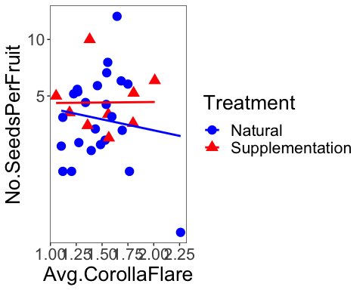

fit<-lme(sqrt(No.SeedsPerFruit)~Treatment*Avg.TubeL, random=~1|Site/Habitat, data=fruit.sw, method="ML", na.action=na.omit)   
anova.lme(fit)

## numDF denDF F-value p-value  
## (Intercept) 1 24 246.74218 <.0001  
## Treatment 1 24 0.91555 0.3482  
## Avg.TubeL 1 24 0.01476 0.9043  
## Treatment:Avg.TubeL 1 24 0.00327 0.9549

summary(fit)

## Linear mixed-effects model fit by maximum likelihood  
## Data: fruit.sw   
## AIC BIC logLik  
## 80.61328 91.08883 -33.30664  
##   
## Random effects:  
## Formula: ~1 | Site  
## (Intercept)  
## StdDev: 0.0001180302  
##   
## Formula: ~1 | Habitat %in% Site  
## (Intercept) Residual  
## StdDev: 0.001923969 0.6638821  
##   
## Fixed effects: sqrt(No.SeedsPerFruit) ~ Treatment * Avg.TubeL   
## Value Std.Error DF t-value  
## (Intercept) 1.9590919 1.2245196 24 1.5998861  
## TreatmentSupplementation 0.4183611 2.5897643 24 0.1615441  
## Avg.TubeL -0.0595821 0.7645515 24 -0.0779307  
## TreatmentSupplementation:Avg.TubeL -0.0893234 1.5613832 24 -0.0572079  
## p-value  
## (Intercept) 0.1227  
## TreatmentSupplementation 0.8730  
## Avg.TubeL 0.9385  
## TreatmentSupplementation:Avg.TubeL 0.9549  
## Correlation:   
## (Intr) TrtmnS Avg.TL  
## TreatmentSupplementation -0.473   
## Avg.TubeL -0.993 0.470   
## TreatmentSupplementation:Avg.TubeL 0.486 -0.994 -0.490  
##   
## Standardized Within-Group Residuals:  
## Min Q1 Med Q3 Max   
## -2.81183381 -0.60145996 0.01005842 0.64904257 2.52018254   
##   
## Number of Observations: 33  
## Number of Groups:   
## Site Habitat %in% Site   
## 3 6

fit<-lme(sqrt(No.SeedsPerFruit)~Treatment*Avg.LobW, random=~1|Site/Habitat, data=fruit.sw, method="ML")   
anova.lme(fit)

## numDF denDF F-value p-value  
## (Intercept) 1 24 214.62277 <.0001  
## Treatment 1 24 0.86042 0.3629  
## Avg.LobW 1 24 0.01262 0.9115  
## Treatment:Avg.LobW 1 24 0.70956 0.4079

summary(fit)

## Linear mixed-effects model fit by maximum likelihood  
## Data: fruit.sw   
## AIC BIC logLik  
## 79.84857 90.32412 -32.92429  
##   
## Random effects:  
## Formula: ~1 | Site  
## (Intercept)  
## StdDev: 1.993909e-05  
##   
## Formula: ~1 | Habitat %in% Site  
## (Intercept) Residual  
## StdDev: 0.08746979 0.6508099  
##   
## Fixed effects: sqrt(No.SeedsPerFruit) ~ Treatment * Avg.LobW   
## Value Std.Error DF t-value  
## (Intercept) 2.4849741 1.049107 24 2.3686570  
## TreatmentSupplementation -1.2256886 1.782355 24 -0.6876792  
## Avg.LobW -0.8500189 1.398207 24 -0.6079350  
## TreatmentSupplementation:Avg.LobW 1.9250836 2.285356 24 0.8423562  
## p-value  
## (Intercept) 0.0262  
## TreatmentSupplementation 0.4982  
## Avg.LobW 0.5489  
## TreatmentSupplementation:Avg.LobW 0.4079  
## Correlation:   
## (Intr) TrtmnS Avg.LW  
## TreatmentSupplementation -0.593   
## Avg.LobW -0.990 0.589   
## TreatmentSupplementation:Avg.LobW 0.610 -0.988 -0.617  
##   
## Standardized Within-Group Residuals:  
## Min Q1 Med Q3 Max   
## -2.44530624 -0.61214422 -0.08262948 0.59374326 2.58556785   
##   
## Number of Observations: 33  
## Number of Groups:   
## Site Habitat %in% Site   
## 3 6

fit<-lme(sqrt(No.SeedsPerFruit)~Treatment*Avg.LobeL, random=~1|Site/Habitat, data=fruit.sw, method="ML")   
anova.lme(fit)

## numDF denDF F-value p-value  
## (Intercept) 1 24 163.40714 <.0001  
## Treatment 1 24 0.76287 0.3911  
## Avg.LobeL 1 24 0.55117 0.4650  
## Treatment:Avg.LobeL 1 24 0.73422 0.4000

summary(fit)

## Linear mixed-effects model fit by maximum likelihood  
## Data: fruit.sw   
## AIC BIC logLik  
## 79.45355 89.9291 -32.72677  
##   
## Random effects:  
## Formula: ~1 | Site  
## (Intercept)  
## StdDev: 2.686009e-05  
##   
## Formula: ~1 | Habitat %in% Site  
## (Intercept) Residual  
## StdDev: 0.1573564 0.6368502  
##   
## Fixed effects: sqrt(No.SeedsPerFruit) ~ Treatment * Avg.LobeL   
## Value Std.Error DF t-value  
## (Intercept) 2.753479 0.947910 24 2.9047905  
## TreatmentSupplementation -2.297002 2.954336 24 -0.7775019  
## Avg.LobeL -1.265399 1.285691 24 -0.9842173  
## TreatmentSupplementation:Avg.LobeL 3.475440 4.055982 24 0.8568676  
## p-value  
## (Intercept) 0.0078  
## TreatmentSupplementation 0.4445  
## Avg.LobeL 0.3348  
## TreatmentSupplementation:Avg.LobeL 0.4000  
## Correlation:   
## (Intr) TrtmnS Avg.LL  
## TreatmentSupplementation -0.333   
## Avg.LobeL -0.985 0.334   
## TreatmentSupplementation:Avg.LobeL 0.324 -0.996 -0.331  
##   
## Standardized Within-Group Residuals:  
## Min Q1 Med Q3 Max   
## -2.1245064 -0.6389516 -0.2328628 0.6667217 2.4881385   
##   
## Number of Observations: 33  
## Number of Groups:   
## Site Habitat %in% Site   
## 3 6

### Both morphs: natural treatment only

#### Seeds per plant

##### Without supplementation treatment

qqnorm(fruit.nat$Total.SeedsPerPlant)  
qqline(fruit.nat$Total.SeedsPerPlant)

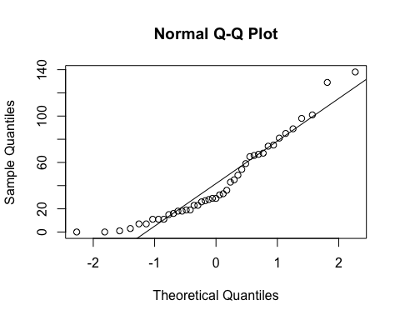

hist(fruit.nat$Total.SeedsPerPlant)

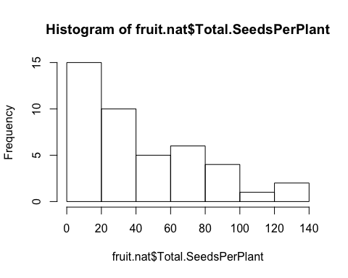

qqnorm(sqrt(fruit.nat$Total.SeedsPerPlant))  
qqline(sqrt(fruit.nat$Total.SeedsPerPlant))

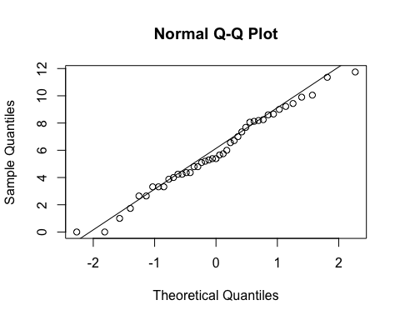

hist(sqrt(fruit.nat$Total.SeedsPerPlant))

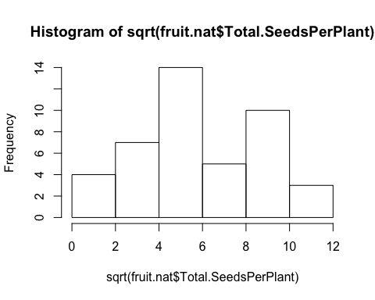

####Site  
anova(lm(sqrt(Total.SeedsPerPlant)~Morph, data=fruit.nat, na.action=na.omit))

## Analysis of Variance Table  
##   
## Response: sqrt(Total.SeedsPerPlant)  
## Df Sum Sq Mean Sq F value Pr(>F)  
## Morph 1 8.81 8.8127 1.0658 0.308  
## Residuals 41 339.03 8.2690

anova(lm(sqrt(Total.SeedsPerPlant)~Site, data=fruit.nat, na.action=na.omit))

## Analysis of Variance Table  
##   
## Response: sqrt(Total.SeedsPerPlant)  
## Df Sum Sq Mean Sq F value Pr(>F)   
## Site 2 68.371 34.185 4.8929 0.01256 *  
## Residuals 40 279.469 6.987   
## ---  
## Signif. codes: 0 '***' 0.001 '**' 0.01 '*' 0.05 '.' 0.1 ' ' 1

TukeyHSD(aov(sqrt(Total.SeedsPerPlant)~Site, data=fruit.nat, na.action=na.omit))

## Tukey multiple comparisons of means  
## 95% family-wise confidence level  
##   
## Fit: aov(formula = sqrt(Total.SeedsPerPlant) ~ Site, data = fruit.nat, na.action = na.omit)  
##   
## $Site  
## diff lwr upr p adj  
## Niwot Ridge-Cumberland Pass 2.7539325 -0.2354300 5.743295 0.0762717  
## Penn Mountain-Cumberland Pass 3.3649434 0.7385034 5.991383 0.0092318  
## Penn Mountain-Niwot Ridge 0.6110109 -1.7314652 2.953487 0.8018811

ggplot(fruit.nat, aes(x=Site,y=No.SeedsPerFruit)) +  
 geom_boxplot() +   
 scale_y_sqrt()+  
 theme_bw() +  
 theme(panel.grid.major = element_blank(), panel.grid.minor = element_blank(), text = element_text(size=20))

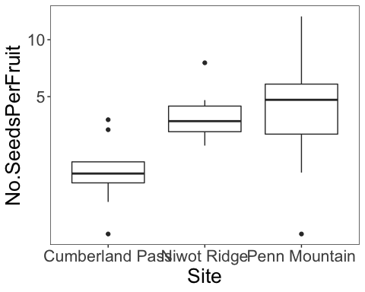

#corolla flare  
fit<-lme(sqrt(Total.SeedsPerPlant)~Avg.CorollaFlare*Morph, random=~1|Site, data=fruit.nat, method="ML", na.action=na.omit)   
anova.lme(fit)

## numDF denDF F-value p-value  
## (Intercept) 1 37 32.17556 <.0001  
## Avg.CorollaFlare 1 37 1.08618 0.3041  
## Morph 1 37 0.08497 0.7723  
## Avg.CorollaFlare:Morph 1 37 0.01911 0.8908

#tube length  
fit<-lme(sqrt(Total.SeedsPerPlant)~Avg.TubeL*Morph, random=~1|Site, data=fruit.nat, method="ML", na.action=na.omit)   
anova.lme(fit)

## numDF denDF F-value p-value  
## (Intercept) 1 37 42.00901 <.0001  
## Avg.TubeL 1 37 0.06453 0.8009  
## Morph 1 37 0.24602 0.6228  
## Avg.TubeL:Morph 1 37 1.24365 0.2720

#### Flower measurements combined via pca (all 4 traits - same as pressed)

measures <- c("Avg.CorollaFlare", "Avg.TubeL", "Avg.LobeL", "Avg.LobW")  
flwr.size<-as.matrix(subset(fruit.nat, select=measures))  
pc<-prcomp(flwr.size,center=TRUE)  
print(pc)

## Standard deviations (1, .., p=4):  
## [1] 0.25076852 0.21385170 0.08529390 0.06907149  
##   
## Rotation (n x k) = (4 x 4):  
## PC1 PC2 PC3 PC4  
## Avg.CorollaFlare 0.8719149 -0.15491858 0.43200595 0.17069137  
## Avg.TubeL 0.1754685 0.98308948 0.01785694 -0.04926474  
## Avg.LobeL 0.3222640 -0.01996539 -0.83421169 0.44703259  
## Avg.LobW 0.3242239 -0.09558605 -0.34226136 -0.87669796

plot(pc, type="l")

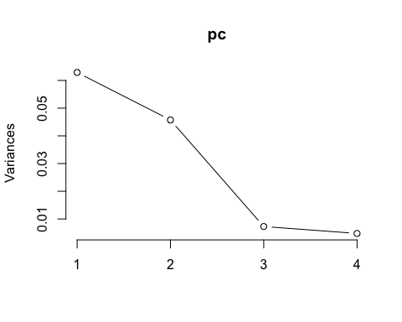

summary(pc)

## Importance of components:  
## PC1 PC2 PC3 PC4  
## Standard deviation 0.2508 0.2139 0.08529 0.06907  
## Proportion of Variance 0.5212 0.3790 0.06029 0.03954  
## Cumulative Proportion 0.5212 0.9002 0.96046 1.00000

pc.extracted <- as.data.frame(predict(pc, newdata=fruit.nat))  
fruit.nat$PC1.all <- pc.extracted$PC1   
# annual fecundity  
fit<-lme(sqrt(Total.SeedsPerPlant)~PC1.all*Morph, random=~1|Site, data=fruit.nat, method="ML", na.action=na.omit)   
anova.lme(fit)

## numDF denDF F-value p-value  
## (Intercept) 1 37 31.278519 <.0001  
## PC1.all 1 37 1.080836 0.3053  
## Morph 1 37 0.065479 0.7995  
## PC1.all:Morph 1 37 0.171193 0.6814

ggplot(fruit.nat, aes(x=Avg.CorollaFlare,y=No.SeedsPerFruit, color=Morph, shape=Treatment)) +  
 scale_shape_manual(values=c(16,17)) +  
 geom_point(size=4) +   
 scale_y_sqrt()+  
 scale_colour_manual(values=c("blue", "red")) +  
 theme_bw() +  
 theme(panel.grid.major = element_blank(), panel.grid.minor = element_blank(), text = element_text(size=20))

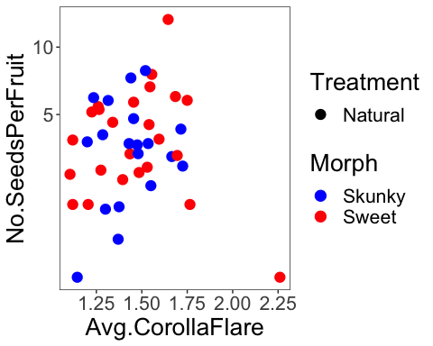

### All morphs: site, habitat and morph are random effects…

#### Seeds per fruit

qqnorm(fruit.sm$No.SeedsPerFruit)  
qqline(fruit.sm$No.SeedsPerFruit)

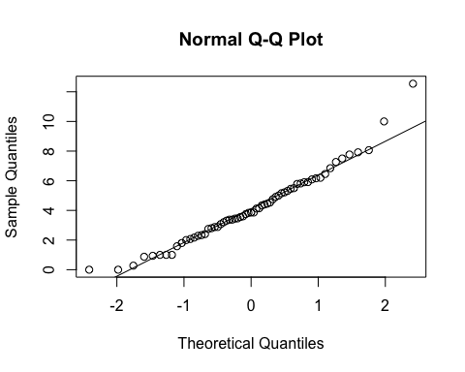

hist((fruit.sm$No.SeedsPerFruit))

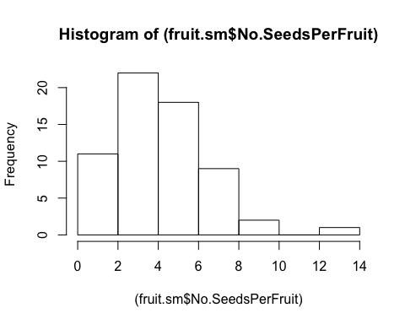

hist(sqrt(fruit.sm$No.SeedsPerFruit))

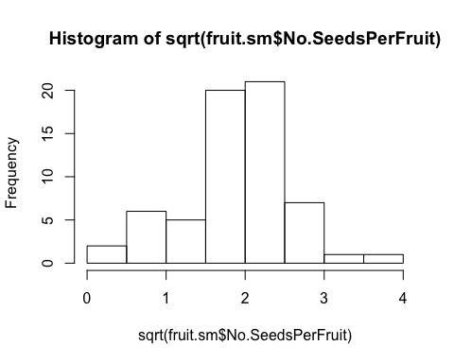

qqnorm(sqrt(fruit.sm$No.SeedsPerFruit))  
qqline(sqrt(fruit.sm$No.SeedsPerFruit))

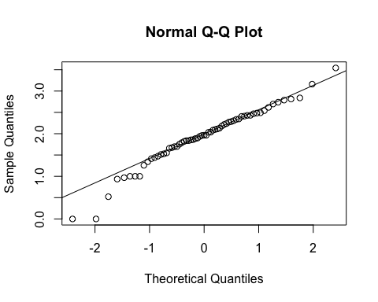

fit<-lme(sqrt(No.SeedsPerFruit)~Treatment*Avg.CorollaFlare, random=~1|Site/Habitat/Morph, data=fruit.sm, method="ML", na.action=na.omit)   
anova.lme(fit)

## numDF denDF F-value p-value  
## (Intercept) 1 49 31.365406 <.0001  
## Treatment 1 49 1.950010 0.1689  
## Avg.CorollaFlare 1 49 1.849166 0.1801  
## Treatment:Avg.CorollaFlare 1 49 1.218113 0.2751

summary(fit) # sign. dif by treatment but difficult to interpret figures, if transformed looks like both go up with corolla flare and only intercept is different...

## Linear mixed-effects model fit by maximum likelihood  
## Data: fruit.sm   
## AIC BIC logLik  
## 126.7399 143.885 -55.36994  
##   
## Random effects:  
## Formula: ~1 | Site  
## (Intercept)  
## StdDev: 0.4879243  
##   
## Formula: ~1 | Habitat %in% Site  
## (Intercept)  
## StdDev: 5.201003e-05  
##   
## Formula: ~1 | Morph %in% Habitat %in% Site  
## (Intercept) Residual  
## StdDev: 0.08833186 0.5419991  
##   
## Fixed effects: sqrt(No.SeedsPerFruit) ~ Treatment * Avg.CorollaFlare   
## Value Std.Error DF  
## (Intercept) 2.6911644 0.6646253 49  
## TreatmentSupplementation -0.9247747 1.0417103 49  
## Avg.CorollaFlare -0.7276656 0.4155911 49  
## TreatmentSupplementation:Avg.CorollaFlare 0.7714139 0.6989460 49  
## t-value p-value  
## (Intercept) 4.049145 0.0002  
## TreatmentSupplementation -0.887746 0.3790  
## Avg.CorollaFlare -1.750917 0.0862  
## TreatmentSupplementation:Avg.CorollaFlare 1.103682 0.2751  
## Correlation:   
## (Intr) TrtmnS Avg.CF  
## TreatmentSupplementation -0.546   
## Avg.CorollaFlare -0.887 0.614   
## TreatmentSupplementation:Avg.CorollaFlare 0.536 -0.988 -0.612  
##   
## Standardized Within-Group Residuals:  
## Min Q1 Med Q3 Max   
## -2.5352836 -0.5825062 -0.1368654 0.5371263 2.9844282   
##   
## Number of Observations: 63  
## Number of Groups:   
## Site Habitat %in% Site   
## 3 6   
## Morph %in% Habitat %in% Site   
## 11

fruit.nat <- subset(fruit.sm, Treatment=="Natural")  
fruit.sup <- subset(fruit.sm, Treatment=="Supplementation")  
  
fit<-lme(sqrt(No.SeedsPerFruit)~Avg.CorollaFlare, random=~1|Site/Habitat, data=fruit.nat, method="ML")  
anova.lme(fit)

## numDF denDF F-value p-value  
## (Intercept) 1 36 29.048421 <.0001  
## Avg.CorollaFlare 1 36 2.966691 0.0936

fit<-lme(sqrt(No.SeedsPerFruit)~Avg.CorollaFlare, random=~1|Site/Habitat, data=fruit.sup, method="ML")  
anova.lme(fit)

## numDF denDF F-value p-value  
## (Intercept) 1 15 595.6668 <.0001  
## Avg.CorollaFlare 1 15 0.0370 0.8501

fit<-lme(sqrt(No.SeedsPerFruit)~Treatment*Avg.TubeL, random=~1|Site/Habitat/Morph, data=fruit.sm, method="ML")   
anova.lme(fit)

## numDF denDF F-value p-value  
## (Intercept) 1 49 45.45105 <.0001  
## Treatment 1 49 2.12481 0.1513  
## Avg.TubeL 1 49 0.01197 0.9133  
## Treatment:Avg.TubeL 1 49 0.06489 0.8000

summary(fit)

## Linear mixed-effects model fit by maximum likelihood  
## Data: fruit.sm   
## AIC BIC logLik  
## 129.5879 146.733 -56.79396  
##   
## Random effects:  
## Formula: ~1 | Site  
## (Intercept)  
## StdDev: 0.3994074  
##   
## Formula: ~1 | Habitat %in% Site  
## (Intercept)  
## StdDev: 3.413248e-05  
##   
## Formula: ~1 | Morph %in% Habitat %in% Site  
## (Intercept) Residual  
## StdDev: 0.04586921 0.5635631  
##   
## Fixed effects: sqrt(No.SeedsPerFruit) ~ Treatment * Avg.TubeL   
## Value Std.Error DF t-value  
## (Intercept) 1.8304037 0.7624397 49 2.4007193  
## TreatmentSupplementation -0.0847926 1.2907410 49 -0.0656930  
## Avg.TubeL -0.0991629 0.4295068 49 -0.2308762  
## TreatmentSupplementation:Avg.TubeL 0.2003806 0.7866185 49 0.2547367  
## p-value  
## (Intercept) 0.0202  
## TreatmentSupplementation 0.9479  
## Avg.TubeL 0.8184  
## TreatmentSupplementation:Avg.TubeL 0.8000  
## Correlation:   
## (Intr) TrtmnS Avg.TL  
## TreatmentSupplementation -0.516   
## Avg.TubeL -0.941 0.546   
## TreatmentSupplementation:Avg.TubeL 0.510 -0.992 -0.547  
##   
## Standardized Within-Group Residuals:  
## Min Q1 Med Q3 Max   
## -3.5040031 -0.5372276 -0.0903510 0.6228894 2.7256253   
##   
## Number of Observations: 63  
## Number of Groups:   
## Site Habitat %in% Site   
## 3 6   
## Morph %in% Habitat %in% Site   
## 11

fit<-lme(sqrt(No.SeedsPerFruit)~Avg.LobeL, random=~1|Site/Habitat/Morph, data=fruit.nat, method="ML")   
anova.lme(fit)

## numDF denDF F-value p-value  
## (Intercept) 1 32 28.727649 <.0001  
## Avg.LobeL 1 32 3.717195 0.0628

summary(fit)

## Linear mixed-effects model fit by maximum likelihood  
## Data: fruit.nat   
## AIC BIC logLik  
## 96.2176 106.7848 -42.1088  
##   
## Random effects:  
## Formula: ~1 | Site  
## (Intercept)  
## StdDev: 0.475752  
##   
## Formula: ~1 | Habitat %in% Site  
## (Intercept)  
## StdDev: 0.1139708  
##   
## Formula: ~1 | Morph %in% Habitat %in% Site  
## (Intercept) Residual  
## StdDev: 0.2068192 0.5717994  
##   
## Fixed effects: sqrt(No.SeedsPerFruit) ~ Avg.LobeL   
## Value Std.Error DF t-value p-value  
## (Intercept) 2.848245 0.6877889 32 4.141162 0.0002  
## Avg.LobeL -1.696629 0.8799928 32 -1.928003 0.0628  
## Correlation:   
## (Intr)  
## Avg.LobeL -0.892  
##   
## Standardized Within-Group Residuals:  
## Min Q1 Med Q3 Max   
## -2.06198107 -0.68738053 -0.04854231 0.74191035 2.37079837   
##   
## Number of Observations: 43  
## Number of Groups:   
## Site Habitat %in% Site   
## 3 6   
## Morph %in% Habitat %in% Site   
## 10

ggplot(fruit.sm, aes(x=Avg.CorollaFlare,y=No.SeedsPerFruit, color=Treatment, shape=Treatment)) +  
 geom_point(size=4) +   
 scale_colour_manual(values=c("blue", "red")) +  
 xlim(0.8,2.4) +  
 ylim(0,15) +  
 geom_smooth(method='lm', aes(linetype=Treatment), fill=NA) +  
 ylab("Number of seeds per fruit") +  
 xlab("Corolla Flare (cm)") +  
 geom_hline(yintercept=0, linetype="dashed") +  
 theme_bw() +  
 theme(panel.grid.major = element_blank(), panel.grid.minor = element_blank(), text = element_text(size=20))

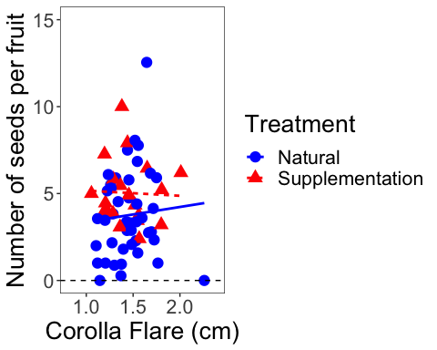

ggplot(fruit.sm, aes(x=Avg.CorollaFlare,y=No.SeedsPerFruit, color=Treatment, shape=Treatment)) +  
 geom_point(size=4) +   
 scale_y_continuous(limits=c(0,15), trans="sqrt") +  
 xlim(0.8,2.4) +  
 scale_colour_manual(values=c("blue", "red")) +  
 geom_smooth(method='lm', aes(linetype=Treatment), fill=NA) +  
 ylab("Number of seeds per fruit") +  
 xlab("Corolla Flare (cm)") +  
 geom_hline(yintercept=0, linetype="dashed") +  
 theme_bw() +  
 theme(panel.grid.major = element_blank(), panel.grid.minor = element_blank(), text = element_text(size=20))

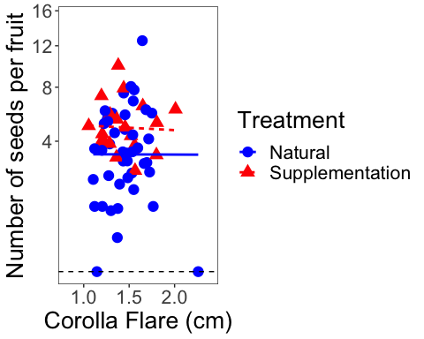

ggplot(fruit.sm, aes(x=Avg.TubeL,y=No.SeedsPerFruit, color=Treatment, shape=Treatment)) +  
 geom_point(size=4) +   
 scale_y_continuous(limits=c(0,15), trans="sqrt") +  
 scale_colour_manual(values=c("blue", "red")) +  
 ylab("Number of seeds per fruit") +  
 xlab("Tube Length (cm)") + geom_hline(yintercept=0, linetype="dashed") +  
 theme_bw() +  
 theme(panel.grid.major = element_blank(), panel.grid.minor = element_blank(), text = element_text(size=20))

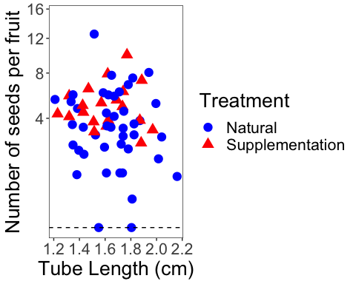

ggplot(fruit.sm, aes(x=Avg.LobeL,y=No.SeedsPerFruit, color=Treatment, shape=Treatment)) +  
 geom_point(size=4) +   
 scale_y_sqrt()+  
 scale_colour_manual(values=c("blue", "red")) +  
 geom_smooth(method='lm', fill=NA) +  
 theme_bw() +  
 theme(panel.grid.major = element_blank(), panel.grid.minor = element_blank(), text = element_text(size=20))

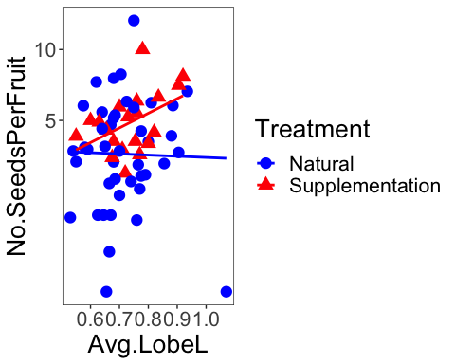

### Add tube length and lobe length to get corolla length

fruit.sm$CorollaL <- fruit.sm$Avg.TubeL + fruit.sm$Avg.TubeL  
fit<-lme(sqrt(No.SeedsPerFruit)~Treatment*CorollaL, random=~1|Site/Habitat/Morph, data=fruit.sm, method="ML")   
anova.lme(fit)

## numDF denDF F-value p-value  
## (Intercept) 1 49 45.45105 <.0001  
## Treatment 1 49 2.12481 0.1513  
## CorollaL 1 49 0.01197 0.9133  
## Treatment:CorollaL 1 49 0.06489 0.8000

summary(fit)

## Linear mixed-effects model fit by maximum likelihood  
## Data: fruit.sm   
## AIC BIC logLik  
## 129.5879 146.733 -56.79396  
##   
## Random effects:  
## Formula: ~1 | Site  
## (Intercept)  
## StdDev: 0.3994074  
##   
## Formula: ~1 | Habitat %in% Site  
## (Intercept)  
## StdDev: 3.413248e-05  
##   
## Formula: ~1 | Morph %in% Habitat %in% Site  
## (Intercept) Residual  
## StdDev: 0.04586921 0.5635631  
##   
## Fixed effects: sqrt(No.SeedsPerFruit) ~ Treatment * CorollaL   
## Value Std.Error DF t-value  
## (Intercept) 1.8304037 0.7624397 49 2.4007193  
## TreatmentSupplementation -0.0847926 1.2907410 49 -0.0656930  
## CorollaL -0.0495814 0.2147534 49 -0.2308762  
## TreatmentSupplementation:CorollaL 0.1001903 0.3933092 49 0.2547367  
## p-value  
## (Intercept) 0.0202  
## TreatmentSupplementation 0.9479  
## CorollaL 0.8184  
## TreatmentSupplementation:CorollaL 0.8000  
## Correlation:   
## (Intr) TrtmnS CorllL  
## TreatmentSupplementation -0.516   
## CorollaL -0.941 0.546   
## TreatmentSupplementation:CorollaL 0.510 -0.992 -0.547  
##   
## Standardized Within-Group Residuals:  
## Min Q1 Med Q3 Max   
## -3.5040031 -0.5372276 -0.0903510 0.6228894 2.7256253   
##   
## Number of Observations: 63  
## Number of Groups:   
## Site Habitat %in% Site   
## 3 6   
## Morph %in% Habitat %in% Site   
## 11

#### Seeds per plant

qqnorm(fruit.sm$Total.SeedsPerPlant)  
qqline(fruit.sm$Total.SeedsPerPlant)

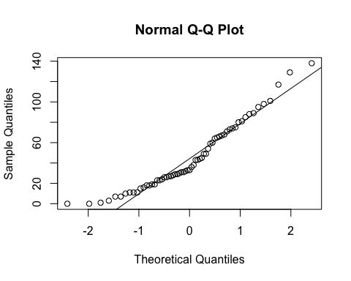

hist(fruit.sm$Total.SeedsPerPlant)

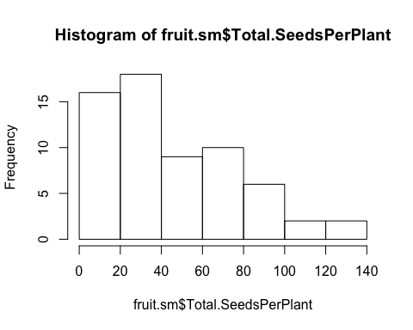

qqnorm(sqrt(fruit.sm$Total.SeedsPerPlant))  
qqline(sqrt(fruit.sm$Total.SeedsPerPlant))

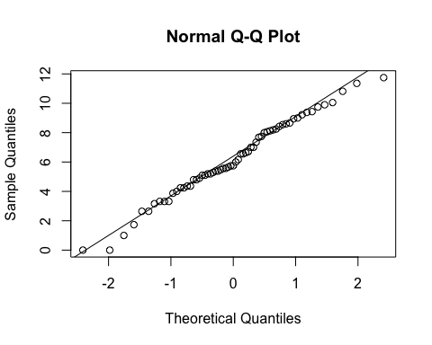

hist(sqrt(fruit.sm$Total.SeedsPerPlant))

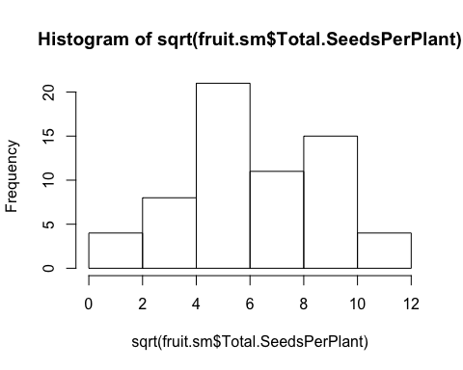

fit<-lme(sqrt(Total.SeedsPerPlant)~Treatment*Avg.CorollaFlare, random=~1|Site/Habitat/Morph, data=fruit.sm, method="ML", na.action=na.omit)   
anova.lme(fit)

## numDF denDF F-value p-value  
## (Intercept) 1 49 34.38847 <.0001  
## Treatment 1 49 0.50732 0.4797  
## Avg.CorollaFlare 1 49 1.57137 0.2160  
## Treatment:Avg.CorollaFlare 1 49 0.14191 0.7080

summary(fit)

## Linear mixed-effects model fit by maximum likelihood  
## Data: fruit.sm   
## AIC BIC logLik  
## 309.7805 326.9255 -146.8902  
##   
## Random effects:  
## Formula: ~1 | Site  
## (Intercept)  
## StdDev: 1.449129  
##   
## Formula: ~1 | Habitat %in% Site  
## (Intercept)  
## StdDev: 0.0001741057  
##   
## Formula: ~1 | Morph %in% Habitat %in% Site  
## (Intercept) Residual  
## StdDev: 0.2469176 2.365834  
##   
## Fixed effects: sqrt(Total.SeedsPerPlant) ~ Treatment * Avg.CorollaFlare   
## Value Std.Error DF  
## (Intercept) 8.566089 2.728460 49  
## TreatmentSupplementation -1.238176 4.506647 49  
## Avg.CorollaFlare -2.195952 1.796581 49  
## TreatmentSupplementation:Avg.CorollaFlare 1.140959 3.028699 49  
## t-value p-value  
## (Intercept) 3.1395330 0.0029  
## TreatmentSupplementation -0.2747445 0.7847  
## Avg.CorollaFlare -1.2222951 0.2274  
## TreatmentSupplementation:Avg.CorollaFlare 0.3767157 0.7080  
## Correlation:   
## (Intr) TrtmnS Avg.CF  
## TreatmentSupplementation -0.575   
## Avg.CorollaFlare -0.936 0.612   
## TreatmentSupplementation:Avg.CorollaFlare 0.565 -0.988 -0.611  
##   
## Standardized Within-Group Residuals:  
## Min Q1 Med Q3 Max   
## -1.9773802 -0.7097765 -0.1428479 0.8041358 2.3328699   
##   
## Number of Observations: 63  
## Number of Groups:   
## Site Habitat %in% Site   
## 3 6   
## Morph %in% Habitat %in% Site   
## 11

fit<-lme(sqrt(Total.SeedsPerPlant)~Treatment*Avg.TubeL, random=~1|Site/Habitat/Morph, data=fruit.sm, method="ML", na.action=na.omit)   
anova.lme(fit)

## numDF denDF F-value p-value  
## (Intercept) 1 49 46.97726 <.0001  
## Treatment 1 49 0.61462 0.4368  
## Avg.TubeL 1 49 0.11153 0.7398  
## Treatment:Avg.TubeL 1 49 0.00234 0.9616

summary(fit)

## Linear mixed-effects model fit by maximum likelihood  
## Data: fruit.sm   
## AIC BIC logLik  
## 311.2647 328.4098 -147.6324  
##   
## Random effects:  
## Formula: ~1 | Site  
## (Intercept)  
## StdDev: 1.211982  
##   
## Formula: ~1 | Habitat %in% Site  
## (Intercept)  
## StdDev: 0.0001179221  
##   
## Formula: ~1 | Morph %in% Habitat %in% Site  
## (Intercept) Residual  
## StdDev: 0.0002299894 2.421856  
##   
## Fixed effects: sqrt(Total.SeedsPerPlant) ~ Treatment * Avg.TubeL   
## Value Std.Error DF t-value  
## (Intercept) 4.527678 3.165492 49 1.4303236  
## TreatmentSupplementation 0.829028 5.490710 49 0.1509875  
## Avg.TubeL 0.559507 1.830152 49 0.3057162  
## TreatmentSupplementation:Avg.TubeL -0.162118 3.350201 49 -0.0483905  
## p-value  
## (Intercept) 0.1590  
## TreatmentSupplementation 0.8806  
## Avg.TubeL 0.7611  
## TreatmentSupplementation:Avg.TubeL 0.9616  
## Correlation:   
## (Intr) TrtmnS Avg.TL  
## TreatmentSupplementation -0.532   
## Avg.TubeL -0.965 0.550   
## TreatmentSupplementation:Avg.TubeL 0.525 -0.992 -0.549  
##   
## Standardized Within-Group Residuals:  
## Min Q1 Med Q3 Max   
## -2.6492255 -0.6631592 -0.2230908 0.7759071 2.2094121   
##   
## Number of Observations: 63  
## Number of Groups:   
## Site Habitat %in% Site   
## 3 6   
## Morph %in% Habitat %in% Site   
## 11

### FLOWER SIZE by habitat and morph

#### Notes from Niki’s last analysis:

##### no difference in flower size by scent morph or habitat => sweet and skunky have the same size flowers

###### flowers are cumberland pass are smaller than niwot ridge & penn mountain.

##### This parallels differences in seed set, but when we test for a direct relationship via regression (see below), there is no difference

##### Perhaps it has more to do with a weather effect, since selection doesn’t vary among sites??? [stilll need to verify this last statement]

qqnorm(flwr.nat$Avg.CorollaFlare)  
qqline(flwr.nat$Avg.CorollaFlare)

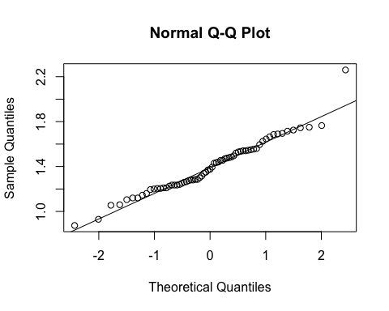

hist(flwr.nat$Avg.CorollaFlare)

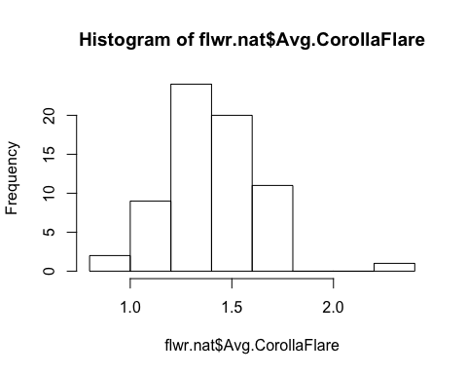

fit<-lm(Avg.CorollaFlare~Site, data=flwr.nat, na.action=na.omit)   
anova(fit)

## Analysis of Variance Table  
##   
## Response: Avg.CorollaFlare  
## Df Sum Sq Mean Sq F value Pr(>F)   
## Site 2 0.88461 0.4423 10.286 0.0001339 ***  
## Residuals 64 2.75216 0.0430   
## ---  
## Signif. codes: 0 '***' 0.001 '**' 0.01 '*' 0.05 '.' 0.1 ' ' 1

TukeyHSD(aov(Avg.CorollaFlare~Site, data=flwr.nat, na.action=na.omit))

## Tukey multiple comparisons of means  
## 95% family-wise confidence level  
##   
## Fit: aov(formula = Avg.CorollaFlare ~ Site, data = flwr.nat, na.action = na.omit)  
##   
## $Site  
## diff lwr upr p adj  
## Niwot Ridge-Cumberland Pass 0.22016082 0.05650121 0.3838204 0.0055154  
## Penn Mountain-Cumberland Pass 0.26943860 0.12355236 0.4153248 0.0001098  
## Penn Mountain-Niwot Ridge 0.04927778 -0.09906877 0.1976243 0.7061896

ggplot(flwr.nat, aes(x=Site,y=Avg.CorollaFlare)) +  
 geom_boxplot() +   
 theme_bw() +  
 theme(panel.grid.major = element_blank(), panel.grid.minor = element_blank(), text = element_text(size=20))

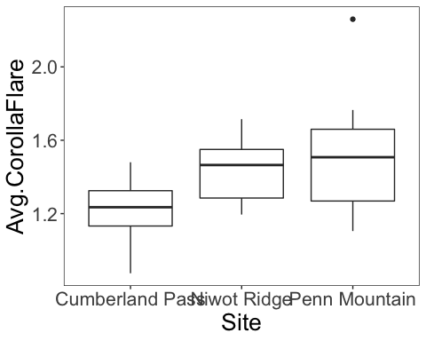

fit<-lme(Avg.CorollaFlare~Site, random=~1|Morph, data=flwr.nat, method="ML", na.action=na.omit)   
anova.lme(fit)

## numDF denDF F-value p-value  
## (Intercept) 1 63 3043.6925 <.0001  
## Site 2 63 10.2855 1e-04

fit<-lme(Avg.CorollaFlare~Habitat*Morph, random=~1|Site, data=flwr.nat, method="ML", na.action=na.omit)   
anova.lme(fit)

## numDF denDF F-value p-value  
## (Intercept) 1 61 326.7009 <.0001  
## Habitat 1 61 1.7298 0.1934  
## Morph 1 61 0.4290 0.5150  
## Habitat:Morph 1 61 0.1262 0.7237

fit<-lm(Avg.CorollaFlare~Site*Morph, data=flwr.nat, na.action=na.omit)   
Anova(fit,type="III")

## Anova Table (Type III tests)  
##   
## Response: Avg.CorollaFlare  
## Sum Sq Df F value Pr(>F)   
## (Intercept) 16.3840 1 380.9275 <2e-16 ***  
## Site 0.1612 2 1.8736 0.1623   
## Morph 0.0814 1 1.8932 0.1739   
## Site:Morph 0.1279 2 1.4865 0.2342   
## Residuals 2.6237 61   
## ---  
## Signif. codes: 0 '***' 0.001 '**' 0.01 '*' 0.05 '.' 0.1 ' ' 1

fit<-lm(Avg.CorollaFlare~Site*Morph*Habitat, data=flwr.nat, na.action=na.omit)   
anova(fit) # unbalanced, so cannot run type 3.

## Analysis of Variance Table  
##   
## Response: Avg.CorollaFlare  
## Df Sum Sq Mean Sq F value Pr(>F)   
## Site 2 0.88461 0.44230 10.1313 0.0001719 ***  
## Morph 1 0.00063 0.00063 0.0145 0.9046879   
## Habitat 1 0.10749 0.10749 2.4623 0.1221465   
## Site:Morph 2 0.08515 0.04258 0.9752 0.3833099   
## Site:Habitat 2 0.06354 0.03177 0.7277 0.4874450   
## Morph:Habitat 1 0.00688 0.00688 0.1577 0.6927604   
## Residuals 57 2.48846 0.04366   
## ---  
## Signif. codes: 0 '***' 0.001 '**' 0.01 '*' 0.05 '.' 0.1 ' ' 1

qqnorm(flwr.nat$Avg.TubeL)  
qqline(flwr.nat$Avg.TubeL)

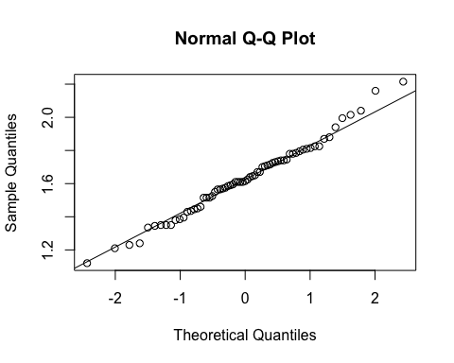

hist(flwr.nat$Avg.TubeL)

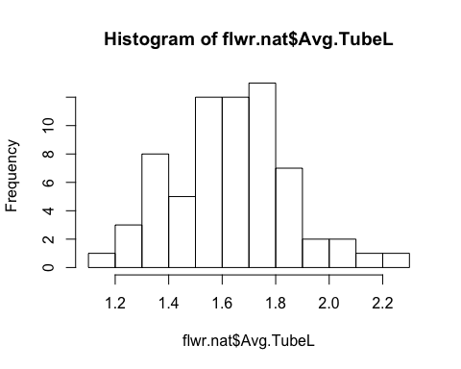

fit<-lm(Avg.TubeL~Site, data=flwr.nat, na.action=na.omit)   
anova(fit)

## Analysis of Variance Table  
##   
## Response: Avg.TubeL  
## Df Sum Sq Mean Sq F value Pr(>F)  
## Site 2 0.0433 0.021657 0.4341 0.6497  
## Residuals 64 3.1927 0.049887

fit<-lme(Avg.TubeL~Habitat*Morph, random=~1|Site, data=flwr.nat, method="ML", na.action=na.omit)   
anova.lme(fit)

## numDF denDF F-value p-value  
## (Intercept) 1 61 3620.624 <.0001  
## Habitat 1 61 1.668 0.2014  
## Morph 1 61 0.663 0.4186  
## Habitat:Morph 1 61 0.608 0.4384

fit<-lm(Avg.TubeL~Site*Morph, data=flwr.nat, na.action=na.omit)   
Anova(fit,type="III")

## Anova Table (Type III tests)  
##   
## Response: Avg.TubeL  
## Sum Sq Df F value Pr(>F)   
## (Intercept) 28.8830 1 609.4369 < 2e-16 ***  
## Site 0.1386 2 1.4621 0.23977   
## Morph 0.0222 1 0.4675 0.49675   
## Site:Morph 0.2398 2 2.5294 0.08804 .   
## Residuals 2.8910 61   
## ---  
## Signif. codes: 0 '***' 0.001 '**' 0.01 '*' 0.05 '.' 0.1 ' ' 1

fit<-lm(Avg.TubeL~Site*Morph*Habitat, data=flwr.nat, na.action=na.omit)   
anova(fit) # unbalanced, so cannot run type 3.

## Analysis of Variance Table  
##   
## Response: Avg.TubeL  
## Df Sum Sq Mean Sq F value Pr(>F)   
## Site 2 0.04331 0.021657 0.4992 0.60967   
## Morph 1 0.06202 0.062016 1.4294 0.23682   
## Habitat 1 0.05313 0.053134 1.2246 0.27310   
## Site:Morph 2 0.28845 0.144226 3.3241 0.04310 *  
## Site:Habitat 2 0.24178 0.120890 2.7863 0.07006 .  
## Morph:Habitat 1 0.07427 0.074267 1.7117 0.19602   
## Residuals 57 2.47309 0.043387   
## ---  
## Signif. codes: 0 '***' 0.001 '**' 0.01 '*' 0.05 '.' 0.1 ' ' 1

measures <- c("Avg.CorollaFlare", "Avg.TubeL", "Avg.LobeL", "Avg.LobW")  
flwr.size<-as.matrix(subset(flwr.nat, select=measures))  
pc<-prcomp(flwr.size,center=TRUE)  
print(pc)

## Standard deviations (1, .., p=4):  
## [1] 0.26375496 0.20976301 0.08825506 0.06486573  
##   
## Rotation (n x k) = (4 x 4):  
## PC1 PC2 PC3 PC4  
## Avg.CorollaFlare 0.8192268 -0.40655518 -0.35567419 -0.19255163  
## Avg.TubeL 0.4468626 0.89354307 -0.01435364 0.04109264  
## Avg.LobeL 0.2435860 -0.08932854 0.87933763 -0.39931394  
## Avg.LobW 0.2642860 -0.16826787 0.31631500 0.89542372

plot(pc, type="l")

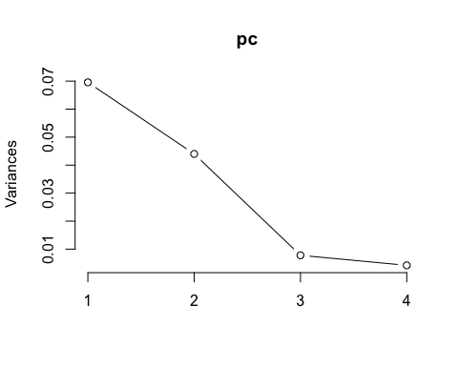

summary(pc)

## Importance of components:  
## PC1 PC2 PC3 PC4  
## Standard deviation 0.2638 0.2098 0.08826 0.06487  
## Proportion of Variance 0.5540 0.3504 0.06203 0.03351  
## Cumulative Proportion 0.5540 0.9045 0.96649 1.00000

pc.extracted <- as.data.frame(predict(pc, newdata=flwr.nat))  
flwr.nat$PC1.all <- pc.extracted$PC1   
qqnorm(flwr.nat$PC1.all)  
qqline(flwr.nat$PC1.all)

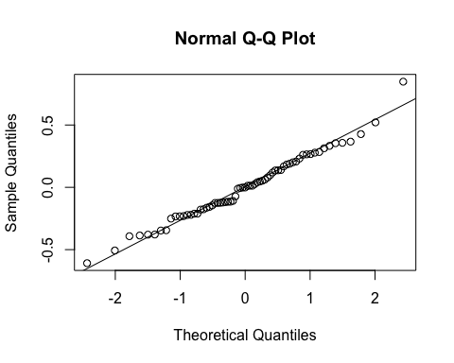

fit<-lm(PC1.all~Site, data=flwr.nat, na.action=na.omit)   
anova(fit)

## Analysis of Variance Table  
##   
## Response: PC1.all  
## Df Sum Sq Mean Sq F value Pr(>F)   
## Site 2 0.6925 0.34625 5.6837 0.005344 **  
## Residuals 64 3.8989 0.06092   
## ---  
## Signif. codes: 0 '***' 0.001 '**' 0.01 '*' 0.05 '.' 0.1 ' ' 1

ggplot(flwr.nat, aes(x=Site,y=PC1.all)) +  
 geom_boxplot() +   
 theme_bw() +  
 theme(panel.grid.major = element_blank(), panel.grid.minor = element_blank(), text = element_text(size=20))

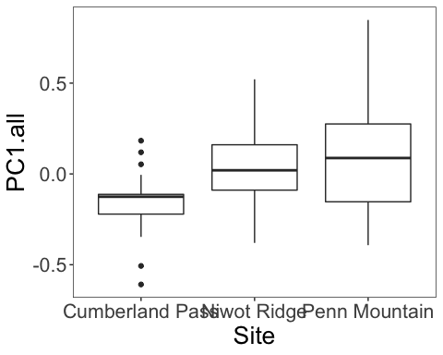

fit<-lme(PC1.all~Habitat*Morph, random=~1|Site, data=flwr.nat, method="ML", na.action=na.omit)   
anova.lme(fit)

## numDF denDF F-value p-value  
## (Intercept) 1 61 0.0324805 0.8576  
## Habitat 1 61 0.1139159 0.7369  
## Morph 1 61 0.2167850 0.6432  
## Habitat:Morph 1 61 0.4024498 0.5282

fit<-lm(PC1.all~Site*Morph, data=flwr.nat, na.action=na.omit)   
Anova(fit,type="III")

## Anova Table (Type III tests)  
##   
## Response: PC1.all  
## Sum Sq Df F value Pr(>F)  
## (Intercept) 0.0884 1 1.4188 0.2382  
## Site 0.1338 2 1.0734 0.3482  
## Morph 0.0915 1 1.4683 0.2303  
## Site:Morph 0.0863 2 0.6924 0.5043  
## Residuals 3.8019 61